A PBL-I Synopsis on
Adversarial Attacks and Data Poisoning in Machine Learning
Submitted to Manipal University Jaipur
Towards the partial fulfillment for the Award of the Degree of
BACHELOR OF TECHNOLOGY
In Computers Science and Engineering
2025-2026

By
Aarna Gupta
2427030695



Under the guidance of
Prof. / Dr. / Ms. Neha Janu

______________________________
Signature of Supervisor

Department of Computer Science and Engineering
School of Computer Science and Engineering
Manipal University Jaipur
Jaipur, Rajasthan

INTRODUCTION TO PROBLEM
(Application based)
Deep Neural Networks (DNNs) and AI systems now power critical applications across healthcare, autonomous vehicles, cybersecurity, finance, and law enforcement
These systems enable breakthrough capabilities in pattern recognition, decision-making, and predictive analytics. However, their data-driven nature introduces a fundamental vulnerability
Adversarial attacks are basically, subtle, intentional manipulations of input data designed to mislead AI models into making incorrect predictions
These modifications are often imperceptible to humans but highly effective against AI systems
Example: Slightly altered traffic signs that cause autonomous vehicles to misclassify stop signs as speed limit signs
Injection of malicious or misleading samples into training datasets to degrade model performance over time is known as data poisoning.
Even minor input manipulations can cause catastrophic failures in mission-critical systems
Attackers exploit the statistical, gradient-based learning mechanisms of DNNs
Gradient-based attacks (FGSM) leverage the model's own internal gradients to rapidly identify optimal input modifications for maximum misclassification

These attacks remain nearly invisible to human observers while causing DNNs to make dangerously confident wrong predictions
AI systems' vulnerability to adversarial manipulation threatens their reliability and trustworthiness in applications where errors can have severe consequences—from misdiagnosed medical conditions to compromised security systems.

This report takes a deep dive into gradient-based adversarial attacks, with a special focus on the Fast Gradient Sign Method (FGSM) and related techniques. The approach involves breaking down how these attacks operate, comparing the effectiveness of current defence strategies, and highlighting important gaps in the research. By analysing attack mechanisms across multiple domains, evaluating defence performance, and bringing together insights from recent literature, the aim is to make these vulnerabilities understandable and to offer practical ways to design AI systems that are more resilient and secure against adversarial manipulation.

AI

CYBERSECURITY
FINANCE
AUTONOMOUS VEHICLES
HEALTHCARE

SELF DRIVEN CARS, MOTION AND TRAFFIC SIGN DETECTION
FRAUD DETECTION
, ALGORITHM TRAINING, BUDGET TRACKNIG
THREAT DETECTION,
ACCESS CONTROL, NETWORK MONITORING
MEDICAL IMAGING, DIAGNOSTICS, PATIENT MONITORING

LITERATURE REVIEW

AUTHOR, YEAR | METHODS | FOCUS AREA | LIMITATIONS
Vassilev, Oprea, Fordyce, Anderson, Davies, Hamin | Comprehensive taxonomy; attack classification (stage, goals, knowledge); mitigations: adversarial training | Taxonomy of adversarial ML attacks & defenses. | Conceptual; empirical defenses; lacks formal benchmarks; evolving threats.
Bena, Anisetti, Damiani, Yeun, Ardagna | Risk-based ensemble: assigns poisoning risk using indicators of poisoning; routes data via round-robin/sink strategy. | Defending against data poisoning using risk-aware ensembles. | Evaluated on small tabular datasets, limited generalization to deep learning.
Pawlicki, Pawlicka, Kozik, Choraś | Meta-survey of papers; categorization of deep-learning models and performance metrics; gap analysis. | Survey of adversarial attacks and detection in DL models. | Inconsistent paper selection; missing standard metrics; lacks structure.
Ndayipfukamiye, Ding, Sarwatt, Philipo, Ning | PRISMA-based review; GAN taxonomy (defensive function, architecture, threat model). | GAN-based methods for cyber threat detection and mitigation. | GANs costly, unstable, and lack standardized benchmarks.
Lakera Team | Survey of poisoning vectors and supply-chain risks; tools: PoisonBench, MCPTox. | Data poisoning in generative AI pipelines. | Poisoning detection & recovery immature; stealthy attacks impactful.
Muthalagu, Malik, Pawar | Adversarial training & abstract interpretation; mixture of attacks for malware detection robustness. | Robust ML for malware evasion defense. | Dependent on adversarial sample quality; complex; dataset-sensitive.
Daniele Angioni, Luca Demetrio, Maura Pintor, Luca Oneto, Davide Anguita, Battista Biggio (2025) | Robustness-Congruent Adversarial Training: a fine-tuning method that applies adversarial training with additional constraints | Secure model updates | Cannot fully prevent negative flips/regression
Maxwell Standen, Junae Kim, Claudia Szabo (2025) | Systematic literature review, new framework (APOSG), taxonomy | - Adversarial ML attacks/defenses in Multi-Agent Reinforcement Learning (MARL) | Few real-world studies, mostly simulations, framework/model gaps
Hang Chen, Qian Xiang, Lei Zhang (2025) | Survey of latest diffusion models and their applications | Image generation, ethics, privacy | High computational cost, limited high-res support, older surveys miss new advances and impacts
Aryal, Gupta, Abdelsalam, Kunwar, Thuraisingham (2024) | Survey of adversarial attacks in malware analysis | ML-based malware detection, attack types/platforms, threat modeling | Few robust defenses, practical challenges

COMPARATIVE STUDY
Attack Type | Main Idea | Domain | Pros | Cons | Current defences
Gradient-based (FGSM) | Uses model gradients to craft adversarial examples | Vision, NLP, GNN | Fast, simple, highly studied | Less effective against advanced defences | Adversarial training, PGD-based training, smoothing, input transformations
Data Poisoning | Injects malicious data into training set | Vision, Tabular, Security | Effective, hard to detect during training | Requires access to training phase, setup | Data sanitization, anomaly detection, risk-based ensemble
Score-based | Uses output confidence scores to guide attack | APIs, deployed models | No model access needed | Needs many output queries | output rounding, query monitoring
Decision-based | Relies on final class label only | APIs, black-box models | Works with just labels | Slower, lots of model queries | Limited output/label exposure, detection of query patterns
Transfer-based | Generates adversarial samples on one model, applies to another | General | Transferability across models | Success rate varies, surrogate needed | Adversarial training across diverse architectures,
Black-box | No model internals, probes via queries | Any | Works even if internals hidden | Query cost, slower, lower success | Diversified training, robust architectures

PROBLEM STATEMENT

Machine learning models, reliant on large datasets, are vulnerable to attacks where manipulated data or inputs cause incorrect predictions or degraded performance. Such adversarial methods threaten critical applications like healthcare, autonomous vehicles, and cybersecurity, as even minimal contamination can significantly undermine system reliability.

OBJECTIVES

- Understand how adversarial attacks and data poisoning compromise AI/ML models.
- Evaluate existing attack types, mitigation strategies, and defence frameworks.
- Design an adaptive, multi-layered defence model integrating risk-based and ensemble techniques.
- Enhance AI resilience through self-correcting and continuous monitoring mechanisms.
- Promote standardized benchmarks, prevention methods, and collaboration in adversarial ML research.

PROPOSED SOLUTION

Understand adversarial vulnerabilities: studying how adversarial attacks and data poisoning compromise AI models, referencing key literature and current meta-surveys.

Evaluate existing methods: Compare and assess major attack types (gradient-based, poisoning, transfer, score, decision-based) using taxonomy and benchmarking studies from recent research.

Select focus domain and datasets: Choose evaluation targets such as image classification, malware detection, or autonomous vehicle data, and prepare relevant datasets for experimenting.

Design adaptive defence mechanisms: Integrate multi-layered defences—including adversarial training, randomized smoothing, formal verification, and data sanitization—to mitigate attacks. Consider risk-aware ensemble approaches (routes high-risk data to isolated models).

Implement continuous monitoring: Apply monitoring and regular re-evaluation to promptly detect and respond to new or evolving threats.

Benchmark and analyse results: Use established metrics to quantify attack success, defence effectiveness, and model robustness; compare with standardized benchmarks highlighted in literature.

Promote collaboration and standardization: Encourage sharing findings, prevention methods, and best practices in the research community to strengthen future AI security.


Fig. proposed solution workflow

SCREENSHOTS

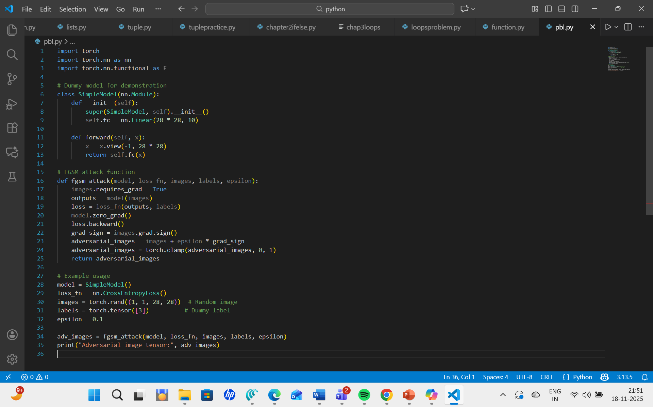

perform an FGSM (Fast Gradient Sign Method) adversarial attack on a simple neural network using PyTorch. FGSM is used to slightly modify input images to fool a neural network into making incorrect predictions.
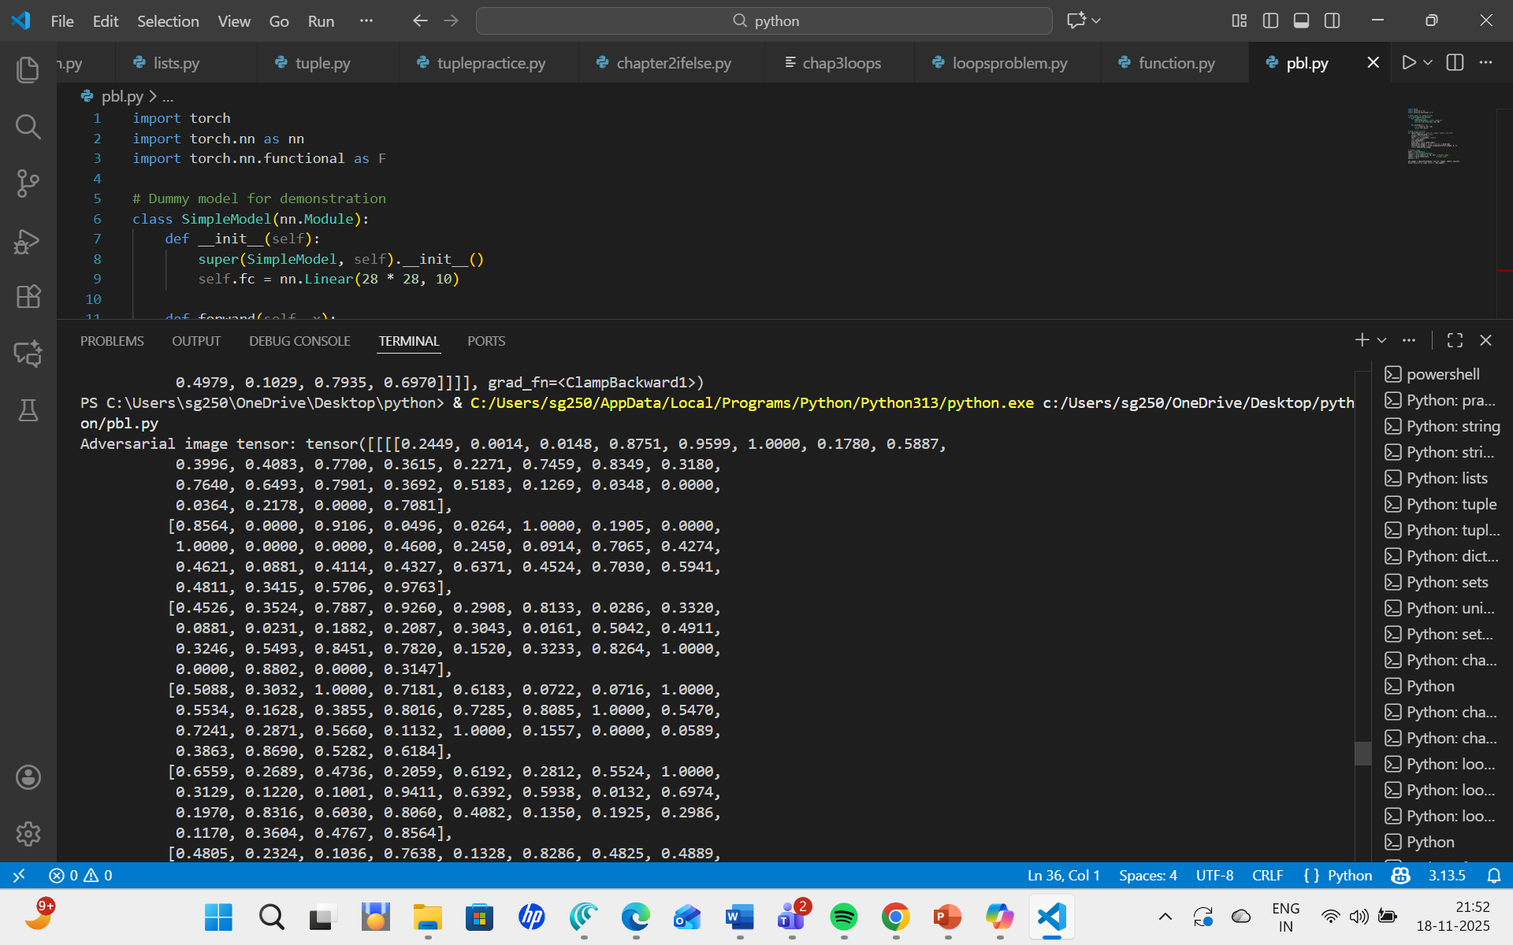
(This is a sample code run to visualise how the attack takes place)

REFERENCES

  - Vassilev, A. Oprea, A. Fordyce, H. Anderson, X. Davies, and M. Hamin, “Adversarial Machine Learning: A Taxonomy and Terminology of Attacks and Mitigations,” NIST, 2024.

  - Bena, M. Anisettes, E. Damiani, C. Y. Yeun, and C. A. Ardagna, “Protecting Machine Learning from Poisoning Attacks: A Risk-Based Approach,” Journal of Information Security and Applications, 2025.

  - Pawlicki, A. Pawlicka, R. Kozik, and M. Choraś, “Survey on Adversarial Attacks and Defences in Deep Learning,” Applied Sciences, 2024.

  - Ndayipfukamiye, X. Ding, D. Sarwatt, C. Philipo, and H. Ning, “A Systematic Review of GAN-based Adversarial Attacks and Defences in Cybersecurity,” IEEE Access, 2025.

  - Ndayipfukamiye, X. Ding, D. Sarwatt, C. Philipo, and H. Ning, “A Systematic Review of GAN-based Adversarial Attacks and Defences in Cybersecurity,” IEEE Access, 2024.

  - Muthalagu, R. Malik, and S. Pawar, “Adversarial Training and Abstract Interpretation for Robust Malware Detection,” Computers & Security, 2023.

